Resilient Florida
A proposal to build locally controlled, rapid molecular disease surveillance capability statewide.

Prepared by:

Randy True – CEO, FloodLAMP Biotechnologies, PBC
randy@floodlamp.bio

Kevin Schallert – COO, FloodLAMP Biotechnologies, PBC
kevin@floodlamp.bio

Table of Contents
Table of Contents 2
About FloodLAMP 3
Resilient Florida Overview 3
Proposal Summary 3
Successful Pilots 3
Key Outcomes of Statewide Rollout 4
Party Responsibilities 4
Phase 1 Implementation Plan - 10 Sites 5
Systems 5
Test Kits 5
Digital Tools 6
Phase 2 Implementation Plan - 50 Sites plus Mobile 7
Phase 3 – Preparedness 7
Proposal Financials 8

About FloodLAMP
FloodLAMP’s mission is to enable globally scalable mass disease screening, for COVID-19 and beyond. We are a Public Benefit Corporation focused on affordable, distributed molecular testing. We have innovated on multiple fronts to create a best-in-class platform that is unique in the testing space. We are rapidly expanding to high priority populations during the pandemic to address the acute unmet need for accessible, effective testing.

Resilient Florida Overview
FloodLAMP is eager to work with the State of Florida to rapidly develop multi-scale molecular surveillance capability at local emergency response agencies. The State is well positioned to support the bring up of processing sites at local emergency agencies because of the cost and time savings inherent to parallel training and deployment. This capability will provide local agencies another viral suppression tool to protect critical human infrastructure at a low cost during normal operations and in emergency response. State sponsored deployments are well suited to hand off to local agency operation once local staff are trained, and local agencies can source test kits on an as needed basis from their discretionary budgets.

The current configuration of our test system supports non-diagnostic testing of COVID-19. In the future, new disease targets can be added, as required by local and state agencies, by changing out only one component of the test (the primers). This plug-and-play capability is a key feature of molecular tests, however most companies in the industry operate as closed, proprietary systems, keeping their test ingredients secret (including the test chemistry and primer sequences). FloodLAMP takes the opposite approach and as a public benefit company, we have a commitment to open protocols and transparency built into our corporate charter. What this means for the Resilient Florida proposal is that the physical infrastructure deployed along with the experience gained through running surveillance screening programs at scale, in partnership with FloodLAMP, extends far beyond this pandemic and specific virus. We’re helping the State of Florida build a new tool, to use when needed for pathogen detection, pandemic response, and flexible critical workforce disease surveillance screening. Together we're adding to local resilience and positioning communities to self-sufficiently respond to the challenges they face.

Proposal Summary
FloodLAMP proposes the State of Florida lead the rapid bring up of sites across the state in a two phase roll out. The State role will be strictly capability building toward local resilience and handoff whereas the local partner agencies will assume financial and program management responsibility. Phase 1 will bring FloodLAMP testing assets in-house to 10 urban, suburban, and rural sites and Phase 2 will expand five–fold. FloodLAMP is equipped to begin Phase 1 immediately and Phase 2 within 10 days of initiation, with completion of both phases within 30 days. The proposal assumes active buy-in from local partner agencies.

Successful Pilots
FloodLAMP has proven that locally controlled surveillance testing can be quickly developed, cheaply maintained, rapidly expanded and sustainably maintained by local agencies. FloodLAMP partnered with the City of Coral Springs and the Town of Davie to develop in-house non-diagnostic screening capability. In two weeks, FloodLAMP converted empty rooms into processing sites (minimalist labs), trained light duty fire fighters to manage, process, interpret and manage test results. The programs maintained low volume COVID-19 suppression screening during low community prevalence times at a minimal test kit and staff cost. The cities were well equipped to respond to increasing case rates with a max capacity of thousands of people tested per day. This capability has reduced workforce infection spread, time to return to work, and informed clinical referrals and therapeutics. Excitingly, confidence in the core test and program have greatly increased, supplanting central lab PCR testing as the most trusted method. It has led to an order of magnitude of increased testing with cost savings to the city general fund. These pilots have shown the resiliency value afforded to low cost and easy to maintain molecular surveillance capability.

Key Outcomes of Statewide Rollout

- Independence and flexibility in implementation of highly accurate, high value infectious disease detection;
- Immediate suppression of COVID19 in critical populations including infrastructure and first responders, for improved health and reduced staffing shortages;
- Surge response capacity to seasonality or new variant outbreaks;
- Coordinated network of EMS sites and personnel trained in all aspects of surveillance program implementation;
- Multi-scale capability that spans metro and rural regions;
- Reduce load and costs from clinical PCR tests for screening;
- Transition from state-sponsored buildout to local management, maintenance, and funding.

Party Responsibilities
- FloodLAMP
  - Deliver test systems and all-in test kits
  - Test technician and participant training
  - Digital app and management software
  - Support and service
  - Quality control
  - Surge staffing

- State of Florida
  - Parallel training and deployment coordination
  - Phase 1 site selection
  - Phase 1 and 2 funding

- Local agency
  - Staffing (need to complete FloodLAMP certification )
  - Space
  - Program management
  - Sample collection logistics
  - Communication of inventory
  - Quality control compliance
  - Resource commitment to fund tests moving past deployment phase

Phase 1 Implementation Plan - 10 Sites
Phase 1 of the rollout comprises bringing up 10 new sites in counties that have critical human infrastructure testing needs. Sites are at the discretion of Florida state leadership and may be a mix of high population counties and metro areas such as Miami-Dade, Palm Beach and Tampa, as well as lower density regions such as Alachua and Leon counties.

Systems

Each FloodLAMP site includes all the equipment and supplies for turnkey operations (the “system”). FloodLAMP calibrates the equipment and coordinates the standard manufacturer warranty.
3 different system configurations are provided:

 | Pipettes | Prep Heater | Amp Heater | Pool Level | Max Capacity per 24hrs | Recommended Daily Max Throughput | Recommended Staff  (single shift)
System Large | 2 premium sets | 2 x Water Bath | 2 x 96 Dry Bath | 4 | 40,000 | 10,000 | 6
System Medium | 1 premium set | 2 x Water Bath | 1 x 96 Dry Bath | 4 | 20,000 | 6,000 | 4
System Mobile | 1 premium set | 1 x 15 Dry Bath | 1 x 40 Dry Bath | 2 | 3,500 | 1,000 | 1

Rapid stand-up and validation assigns a FloodLAMP staff scientist to synchronously support the remote set up of the site and initial validation runs. This process quickly turns an empty room into a fully operational test processing site with high throughput capability.

Staffing for the sites will be a mix of FloodLAMP Test Technicians (test operators) and newly trained EMS/municipal staff. Technical training and certification is achieved through a remote training course with live, as-needed support to train agency personnel to run the FloodLAMP QuickColorTM test system. Completion comes with a FloodLAMP certification.

Test Kits

FloodLAMP All-in Test Kits are unique in the space because they are inclusive of all components required to run large scale testing programs. The kits include collection materials that test up to four people per pool ($2 per person tested), software, and a digital app to manage collection, operations and reporting, as well as all laboratory consumables and reagents. FloodLAMP manages test kit orders for processing sites so they can easily update expected throughput and have their inventory restocked each week on a per test basis. All-in Test Kits contain all of the reagents (liquids needed for the test) and plastic consumables (tubes, pipette tips, plates), as well as the sample collection kit materials (QR coded tubes and nasal swabs), necessary to run the test. These are provided on a per reaction (or per pool) basis and indexed to the LAMP reaction master mix.

Digital Tools

FloodLAMP has custom created digital tools to facilitate the testing process. They serve three key user groups:
- Participants
  - App for iOS and Android
  - Supports at-home collection
  - Collection workflow enables in-app accessioning of tubes (QR code scan) and listing of pool participants per tube
  - Status/history view displays all collection events recorded in the system, and whether the screening is complete.
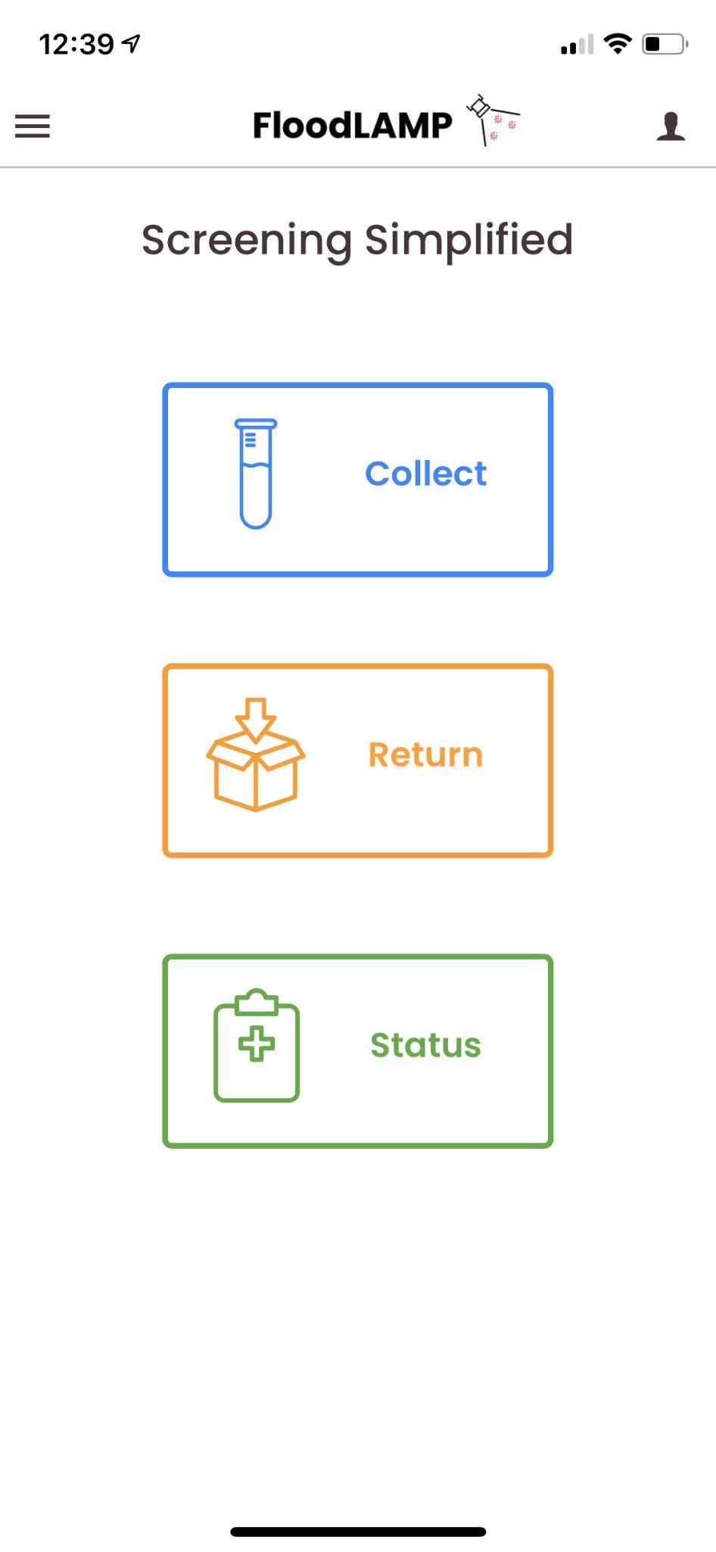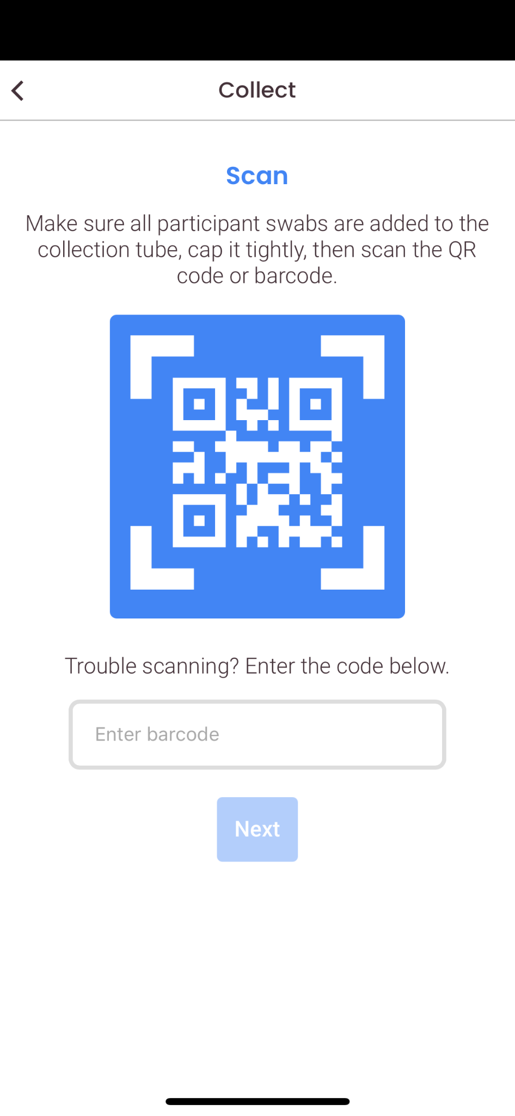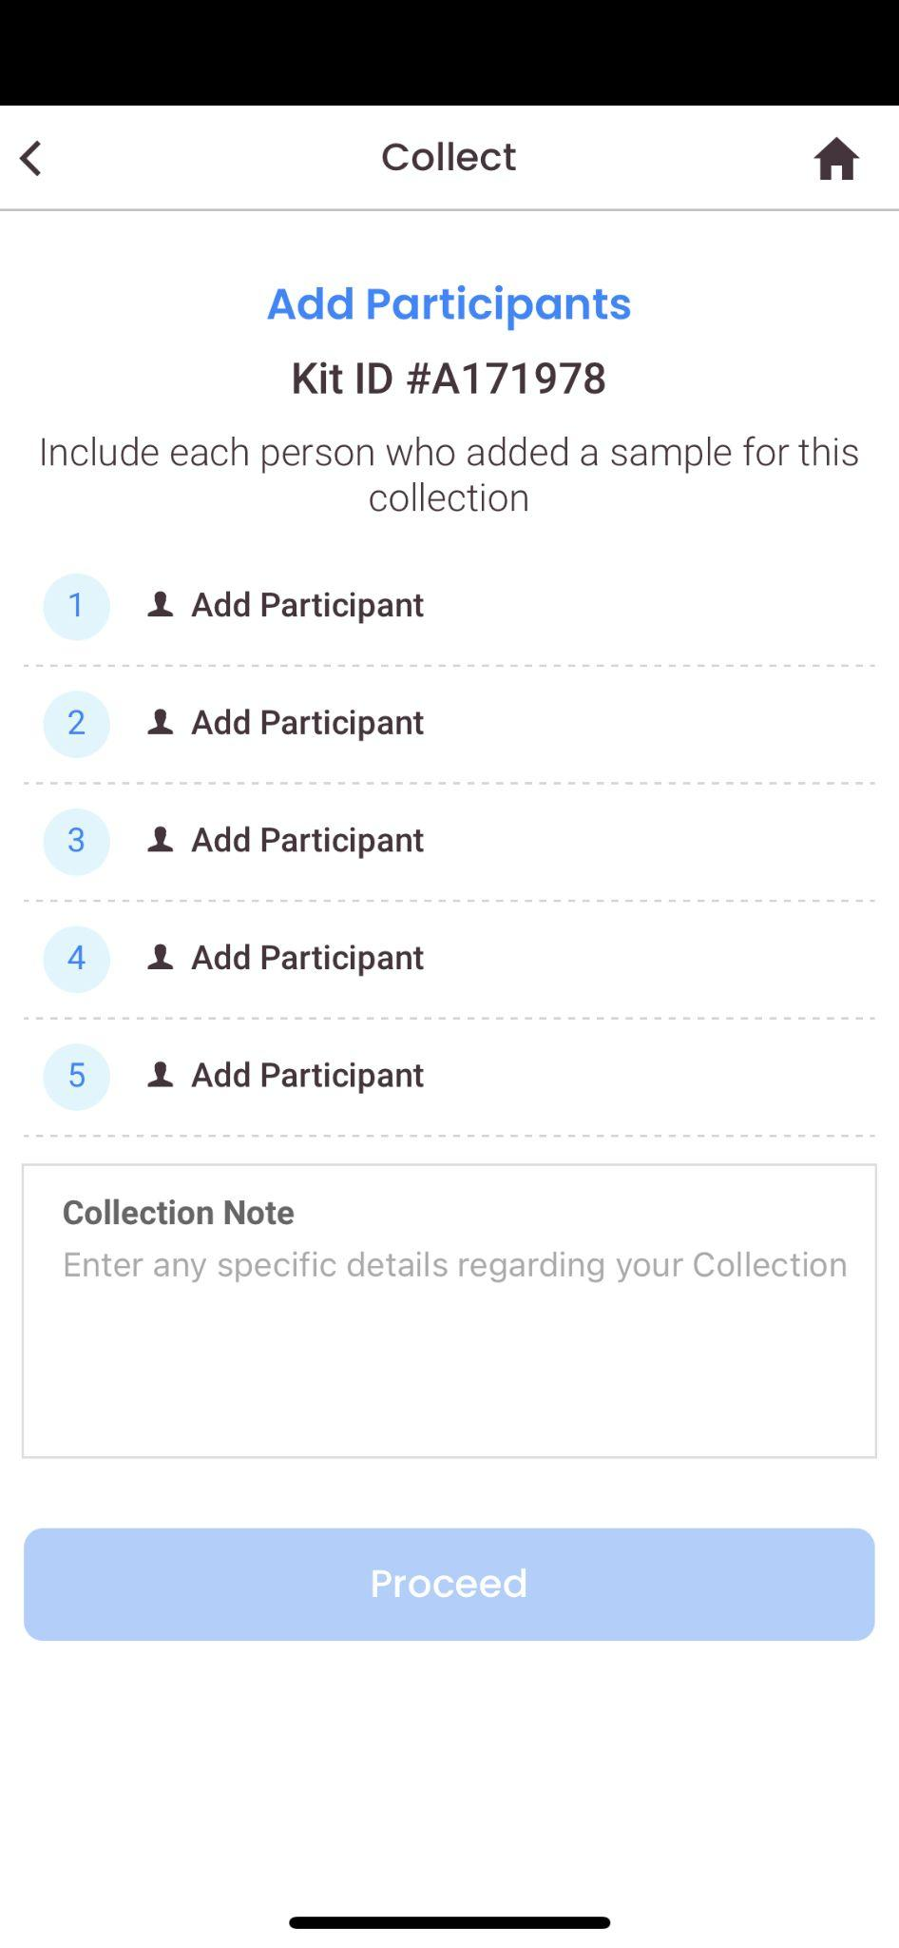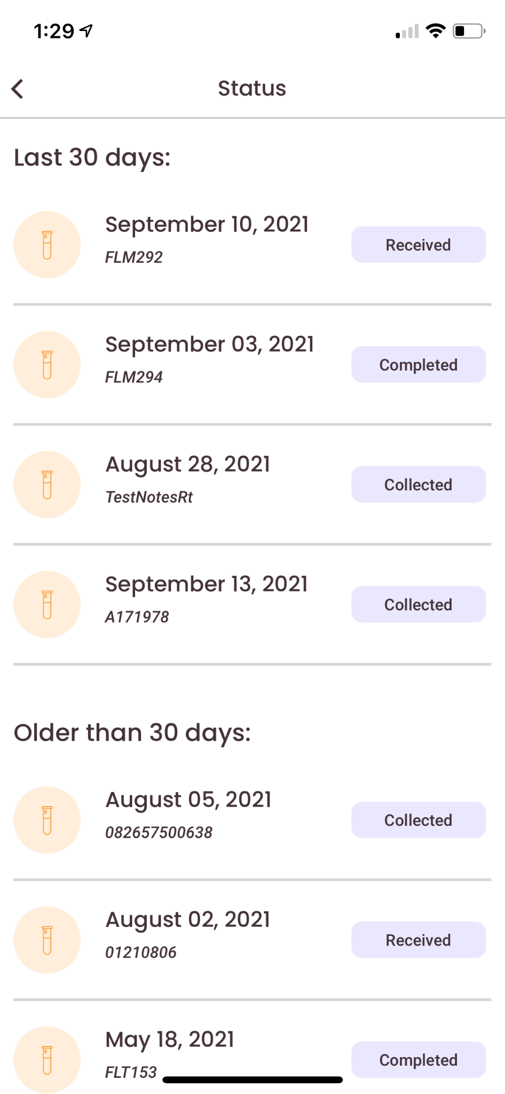
- Staff
  - App for iOS and Android
  - Intake and track tubes
  - Set status on test process (visible to participants)
  - Report results on tubes
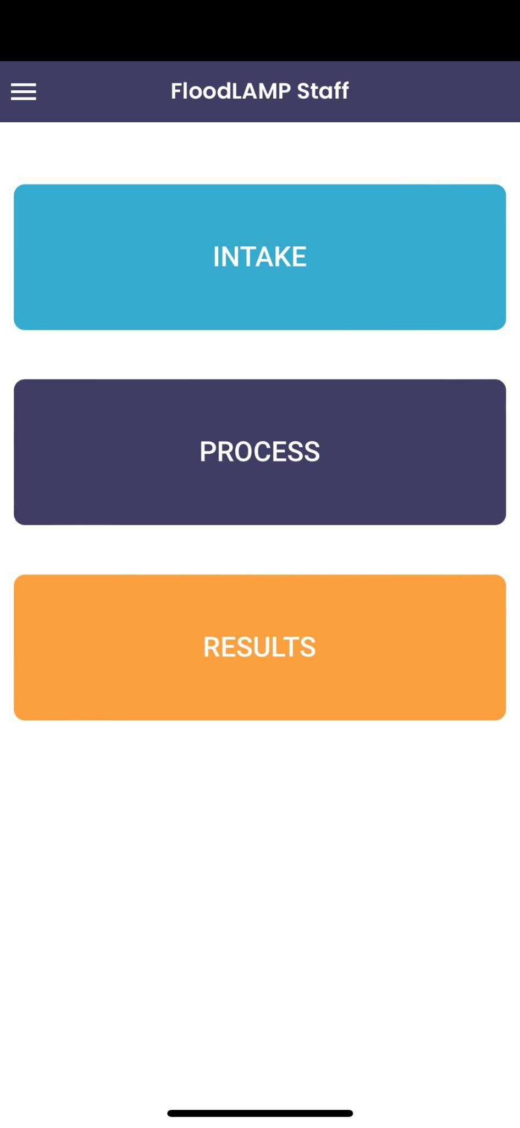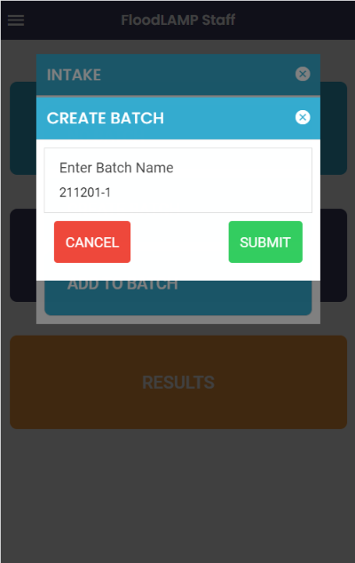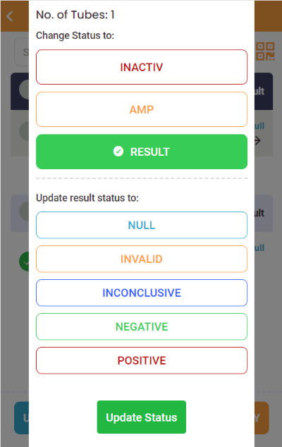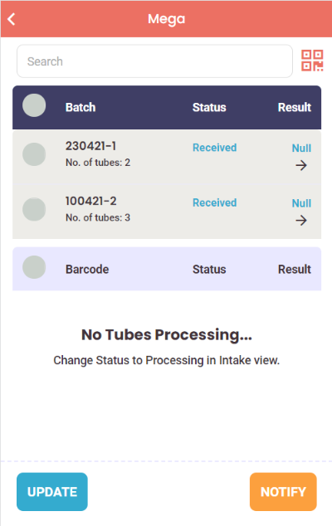

- Administrative Staff
  - Desktop web app
  - Manage and update user accounts
  - View comprehensive history of collected samples and status
  - Search individual entries by tube ID or name
  - Control settings for participant app information pages
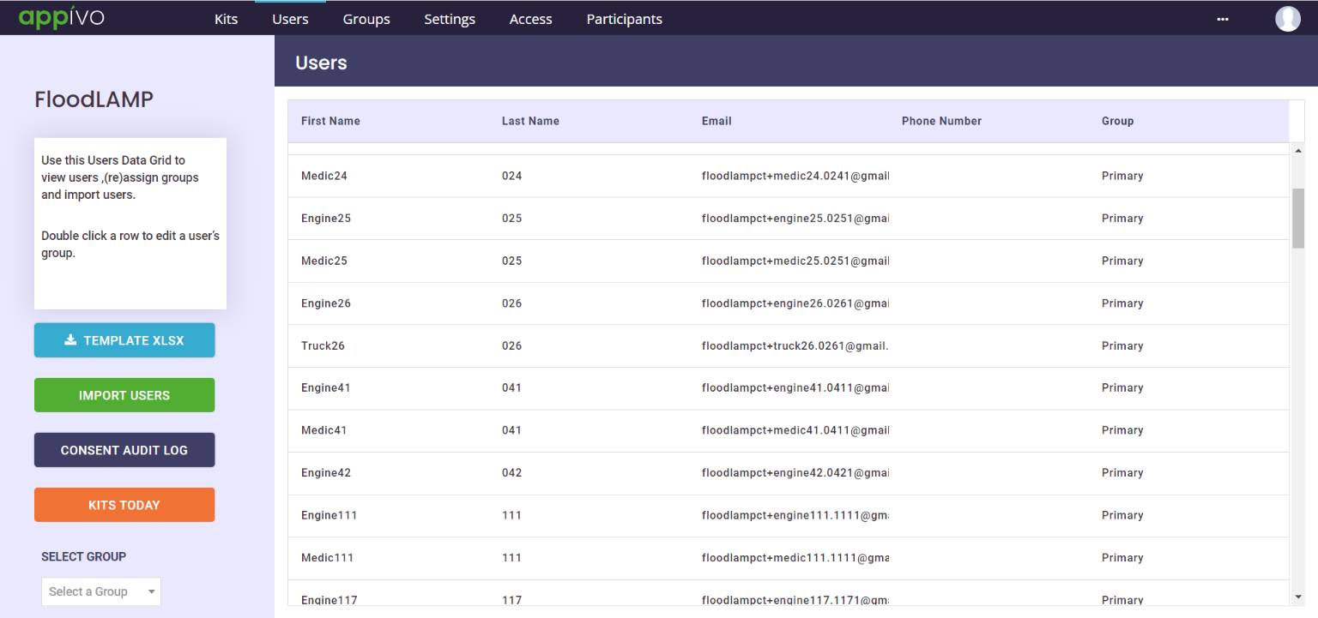

Phase 2 Implementation Plan - 50 Sites plus Mobile
Phase 2 builds on the Phase 1 deployments to scale up to 50 sites total. Additionally 10 mobile systems are provided for portable and/or rapid response testing needs.

Selection of deployment sites as well as implementation details will be informed by needs discovered during execution of Phase 1. Critical supplies for Phase 2 are secured by deposits included in Phase 1.

Phase 3 – Preparedness
FloodLAMP will work directly with local agencies to sustainably manage test capability. FloodLAMP will work with the State of Florida on mobile and pop-up site infrastructure to add capacity during emergency response.

Proposal Financials
Item | Unit Type | Unit Cost | Phase 1 | Phase 1 Totals | Phase 2 | Phase 2 Totals
Systems¹
System Large | Per Site | $18,000 | 4 | $72,000 | 6 | $108,000
System Medium | Per Site | $11,000 | 6 | $66,000 | 34 | $374,000
System Mobile | Per System | $6,000 |  |  | 10 | $60,000
Rapid Stand Up & Validation | Per Site | $8,000 | 10 | $80,000 | 40 | $320,000
 |  |  |  | $218,000 |  | $862,000
Staff²
FloodLAMP Lab Technicians | Per Person Per Week | $5,000 | 20 | $100,000 | 80 | $400,000
Technical Training & Certification | Per Person | $2,000 | 20 | $40,000 | 80 | $160,000
 |  |  | Subtotal | $140,000 | Subtotal | $560,000
Licenses
FloodLAMP Digital Suite License | 1 year | incl with Test Kit purchase
FloodLAMP QuickColor(TM) COVID19 Test License | 1 year | incl with Test Kit purchase
All-in Test Kits¹
Reagents and Consumables | Per Reaction/Pool | $8 | 40,000 | $320,000 | 300,000 | $2,400,000
Collection Kit Materials | Per 4 Person Pool | incl w Test Kits | 40,000
 |  |  | Subtotal | $320,000 | Subtotal | $2,400,000
Deposits
Systems | critical supplies | $1,200 | 40 | $48,000 | 50 | $60,000
Test Kits | critical consumables | $0.80 | 300,000 | $240,000 | 600,000 | $480,000
 |  |  | Subtotal | $288,000 | Subtotal | $540,000
 |  |  | Phase 1 Total | $966,000 | Phase 2 Total | $4,362,000

Terms
(1) delivery 10 days from PO
(2) as needed and utilized, not to exceed without approval

